ER Diagram :

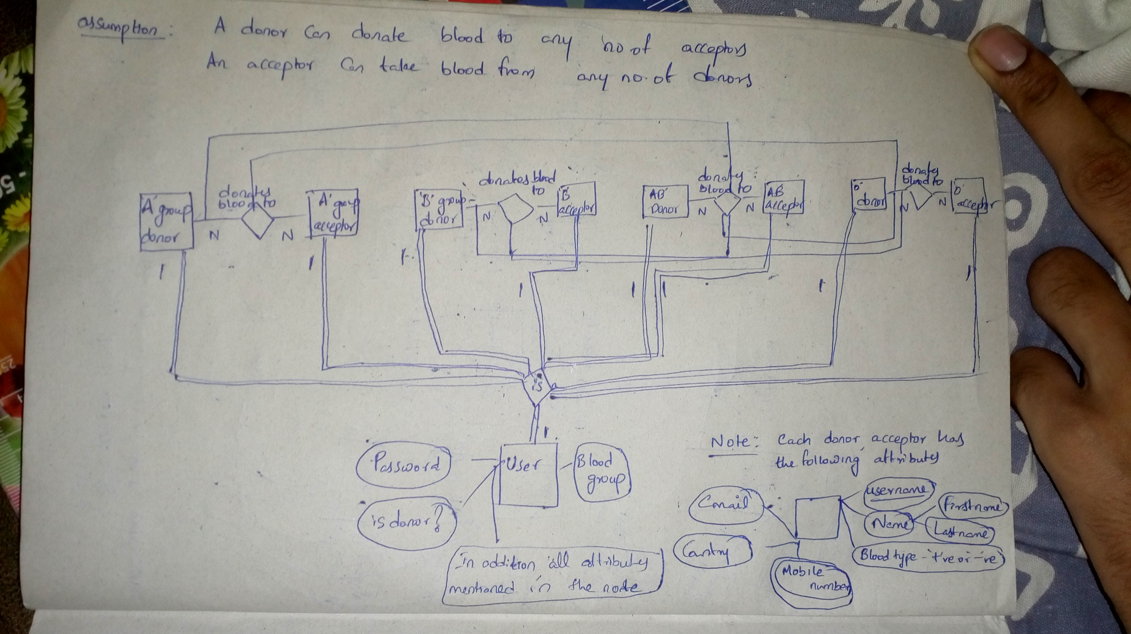

Relational Schema :

User(username, password, isDonor, bloodGroup, name, mobile, email, country)
'A' Donor(username, blood-pos or neg, name, mobile, email, country)
'A' Acceptor(username, blood-pos or neg, name, mobile, email, country)
'B' Donor(username, blood-pos or neg, name, mobile, email, country)
'B' Acceptor(username, blood-pos or neg, name, mobile, email, country)
'AB' Donor(username, blood-pos or neg, name, mobile, email, country)
'AB' Acceptor(username, blood-pos or neg, name, mobile, email, country)
'O' Donor(username, blood-pos or neg, name, mobile, email, country)
'O' Acceptor(username, blood-pos or neg, name, mobile, email, country)

Explanation :

- For every entity, username is the primary key
- Mobile number is a multivalued attribute which means more than one mobile number may exist.
- Name is a composite attribute as it is the composition of first and last names.
- As every donor can donate blood to any number of acceptors the cardinality of donor is N.
- As every acceptor can take blood from any number of donors it's cardinality is N
- As every user can be a particular blood group donor or acceptor the cardinality of the user is 1.
- A donor or acceptor can only be as a single user and can't be more than one user. So, it's cardinality is 1.
- Every donor may not get chance to donate blood(Acceptor may not be present) so the participation of the donor is not full.
- Similarly, every acceptor may not get required blood so the participation of the acceptor is not full
- On the other hand every user must be either a donor or an acceptor which means the user participation is full.
- Every donor and acceptor is a user so their participation is full towards the user.
- 'A' group donor can donate blood to 'A' and 'AB' group acceptors(Rh factor should be same).
- 'B' group donor can donate blood to 'B' and 'AB' group acceptors(Rh factor should be same).
- 'AB' group donor can donate blood to 'AB' group acceptors(Rh factor should be same).
- 'O' group donor can donate blood to all acceptors(Rh factor should be same).

